Bridgepoint Parts Catalog

Section III: Gaskets Page 1

PP43-807094

Gasket Waste Tank Lid

Prochem TM

Prochem: Bruin, Bear, Bruin II, Legend, Legend SE & Performer. Bridgepoint: Lancer

PP43-807541

Gasket Waste Tank Lid

Prochem TM
Prochem: Blazer Plus

PP43-807519

Gasket Waste Tank Lid

Prochem TM
Prochem: Blazer

PP43-807107

Gasket Waste Tank Lid

Prochem TM
Prochem: Performer 405 & Power Vac II (Mfg. Before 5/99)

PP43-807103

Gasket Waste Tank Lid

Prochem TM
Prochem: Oil Fired TM & Trailblazer
Bridgepoint: Saber & Saber 2000

PP43-807559

Gasket Waste Tank Lid

Prochem TM
Prochem: Performer 405 & Power Vac II (Mfg. After 5/99)

(After 5/99)

PP43-807010

Gasket Waste Tank Lid

28” x 3/4”
Prochem: Cub, Cub XL, 100A & 150
Bridgepoint: System IV

PP43-807546

Gasket Waste Tank Lid

Prochem 100 gal Tank

Basket Side
Prochem: Performer, Performer 405 & Power Vac II

PP43-807011

Gasket Waste Tank Lid

12” x 3/4”
Prochem: Cub, Cub XL, 100A & 150
Bridgepoint: System IV

PP43-807547

Gasket Waste Tank Lid

Prochem 100 gal Tank

Filter Side
Prochem: Performer, Performer 405 & Power Vac II

PP43-807573

Gasket Waste Tank Lid

Basket Side
Prochem: Performer 805

PP43-807565

Gasket Waste Tank Lid

Prochem PTO

Prochem: PTO

PP43-807572

Gasket Waste Tank Lid

Filter Side
Prochem: Performer 805

PP790620

Gasket Waste Tank Lid
Prochem: Legend XL & Peak

PP790351

Gasket Waste Tank Lid

Filter Side
Prochem: Apex, Everest &
Everest HP

PP790448

Gasket Waste Tank Lid

Basket Side
Prochem: Apex, Everest &
Everest HP

PP86318530

Gasket Waste Tank Lid

Prochem TM
Prochem: Peak GTX w/ 60 gal waste tank



Bridgepoint Parts Catalog

Section III: Gaskets Page 2

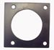

PP43-807080

Gasket – Silencer Outlet

Preheater housing Inlet
Prochem: Trailblazer, Bruin, Bruin II, Bear, Legend, Legend SE, Blazer, Blazer Plus & Performer
Bridgepoint: Lancer, Saber & Saber 2000

PP43-807108

Gasket – Silencer Outlet

Preheater housing Inlet
Prochem: PTO, Performer 405 &
Power Vac II

PP42-902212

Gasket Exhaust to Heat Exchanger
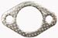

PP43-807049

Gasket Cover Heli-Coil

Heat Exchanger
Prochem: 800A, Bear, Performer,
Performer 405, Everest, Everest HP, Peak & PTO



PP43-807087

Gasket Exhaust Diverter Valve
Prochem: Performer, Performer 405
& Performer 805

PP43-807051

Gasket Manifold Fittings

Heli-Coil Heat Exchanger
Prochem: 800A, Bear, Performer,
Performer 405, Everest, Everest HP, Peak & PTO

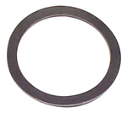

PP43-807086

Gasket Flange - Exhaust

Heat Exchanger

Prochem: Trailblazer, Bruin,
Bruin II, Bear, Legend, Legend SE, Performer & Performer 405
Bridgepoint: Lancer, Saber & Saber 2000

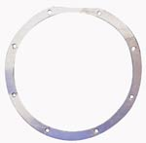

PA010

Gasket Vac Motor 5.7”

5/8” Thick – 1 Side Adhesive
Olympus Portables
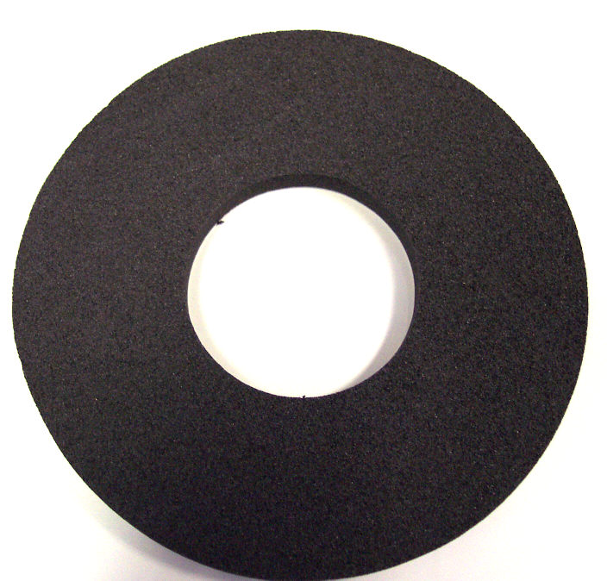

PP43-807090

Gasket – Adapter Plate

Waste Tank Bulkhead



PP43-807110

Gasket Vac Motor 5.7”

3/8” Thick – 1 side Adhesive
My-Tee Part # G004

PP43-807092

Gasket – Waste Tank

Bulkhead Fitting

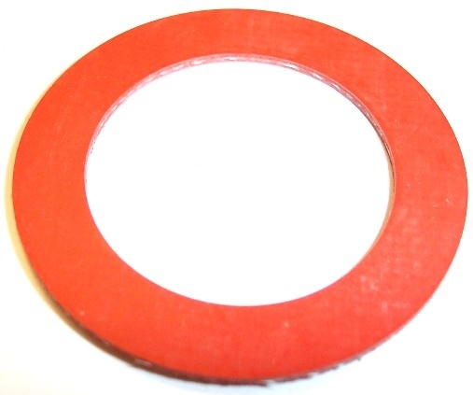

PP43-807526

Gasket Vac Motor 4.8”

1/4” Thick – 1 side Adhesive
Power Spot (MA40) & Spot Pro
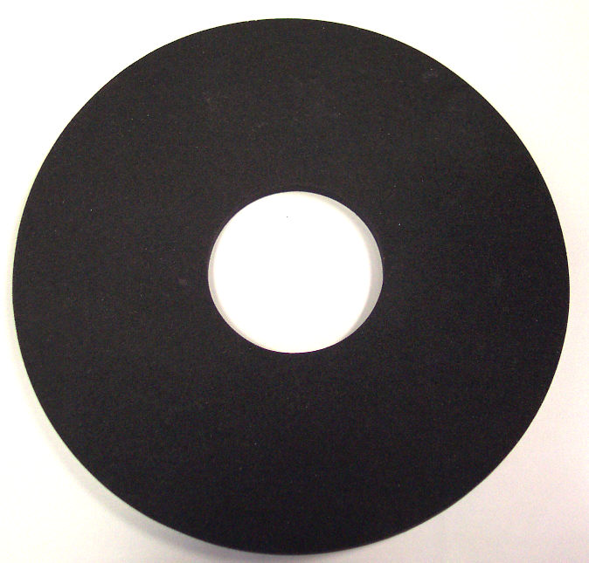

PP33-900081

Gasket Magneto Cover
Prochem: 100A, 150 & Oil Fired TM

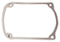

PMG005

Gasket Waste Tank
EX Portable Extractors

PP43-807513

Gasket Valve – Upholstery Tool

Prochem TM Tool

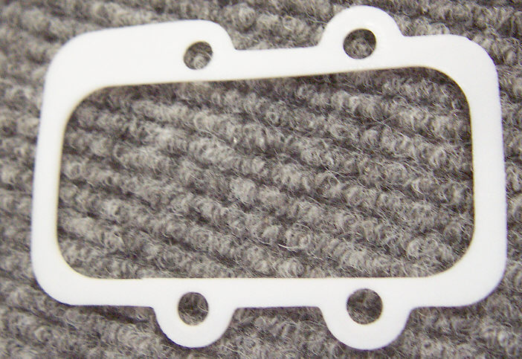

NM5004A

O-Ring Waste Tank Seal

Olympus Portable Extractor

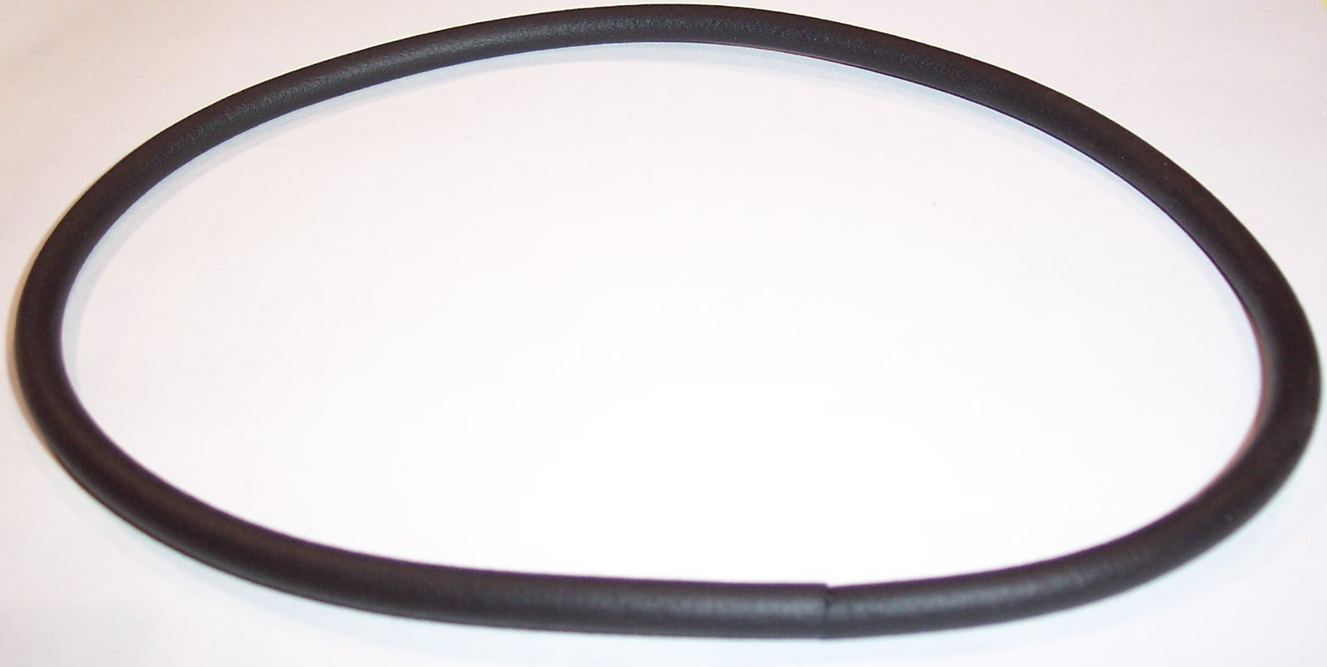

NM5059

Gasket Waste Tank

Olympus Portable Extractor
Seal between Lid Assy & tank
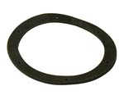

PKLG02.1

Gasket Cover Kleen Rite

3” Upholstery Tool


PKLG02.2

Gasket Valve Kleen Rite

3” Upholstery Tool

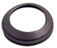
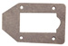

NM3019

Gasket Dump Valve

1-1/2” Gate Valve

Bridgepoint Parts Catalog

Section III: Gaskets Page 3

PHY057-047

Gasket Felt RX-20

PP05-008002

Adhesive – Lid Gaskets
Urethane Adhesive/Sealant
10.3 Fl. Oz. (Fits Caulking Gun) Brand Name may vary

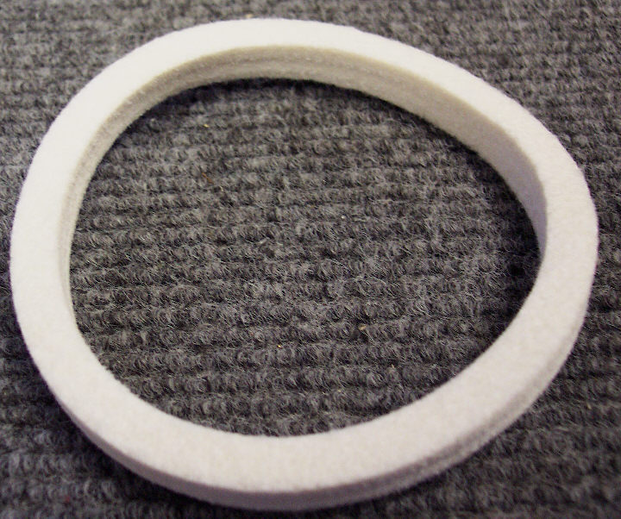

PHY057-048

Gasket Head Skid RX-20

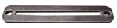

PP43-807041

Gasket Inline Strainer
For PP14-806528 Strainer


PP43-807067
Gasket Nissan Thermostat Prochem: 800A, Bear, Everest, Everest HP, Performer, Performer 405 & Power Vac II



PHY057-056

Gasket Blower CDS 4.2
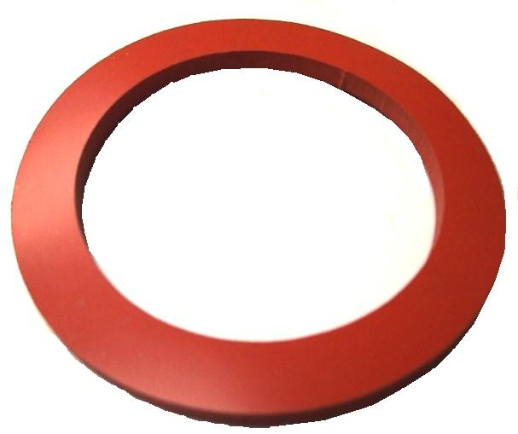

PHY057-062

Gasket Blower CDS 4.7

PHY057-038

Gasket Preheater Spitfire 4.0


PP58-700027

Gasket Preheater Rear /Bottom
Prochem: Trailblazer, Bruin, PTO, Bruin II, Bear, Legend, Legend SE, Blazer, Blazer Plus, Performer & 405
Bridgepoint: Lancer, Saber & Saber 2000

PSD027

Inner Gasket - Window channel

Steamin Demon


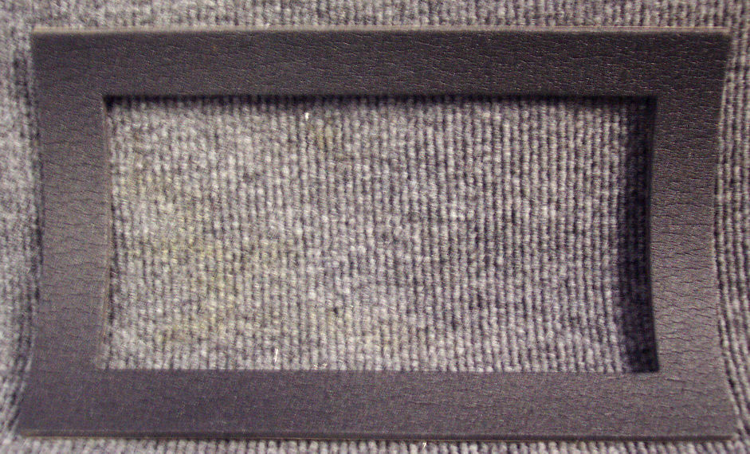

PHY057-146

Gasket Diverter Valve
Hydramaster: Maxx 450D, Maxx 470D, Spitfire 4.0 w/diverter & Boxxer 421 Bridgepoint: Javelin
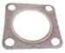

PP43-807081

Gasket Preheater Cover
Prochem: Trailblazer, Bruin, PTO, Bruin II, Bear, Legend, Legend SE, Blazer, Blazer Plus, Performer & 405. Bridgepoint: Lancer, Saber & Saber 2000

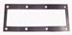

PHY052-015

Gasket 2” Bulkhead Fitting



PP43-807119

Gasket Preheater Cover
Prochem: Performer 805
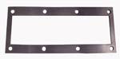

PHY057-177

Gasket Exhaust 1-1/2” Donut

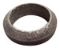

PP58-700036

Gasket Preheater

Rear and Bottom
Prochem: Performer 805

PP43-807567

Gasket Hydraulic Oil Filter - PTO
Prochem: PTO

PP790039

Gasket Silencer Outlet – HE Inlet
Prochem: Apex, Everest,
Everest HP, Legend XL & Peak

PP790343

Pad - Heat Exchanger Bottom
Prochem: Apex, Everest,
Everest HP, Legend XL & Peak

PP790423

Pad - Heat Exchanger Rear
Prochem: Apex, Everest,
Everest HP, Legend XL & Peak

PP790050

Gasket - Heat Exchanger Cover
Prochem: Apex, Everest,
Everest HP, Legend XL & Peak

Bridgepoint Parts Catalog

Section III: Gaskets Page 4

PHY057-203

Gasket Middle Piece

Maxx Air Waste Tanks

PHY057-202

Gasket End Piece

Maxx Air Waste Tanks
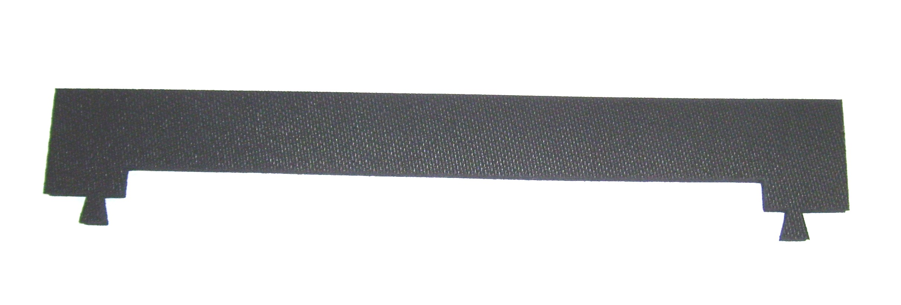
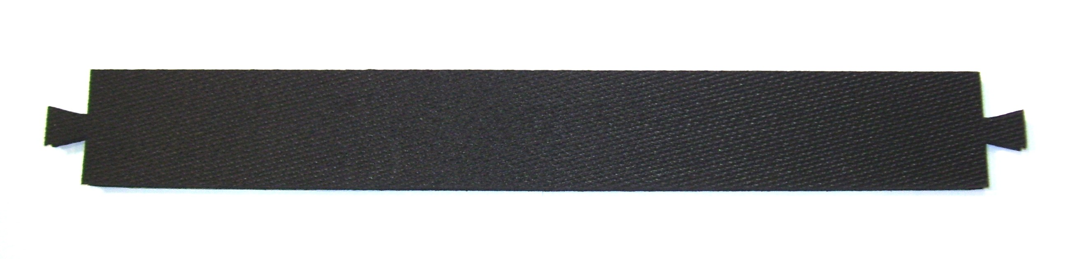

PHY057-204

Gasket Side Piece 70gal tank

Maxx Air Waste Tanks

PHY057-205

Gasket Side Piece 100gal tank

Maxx Air Waste Tanks

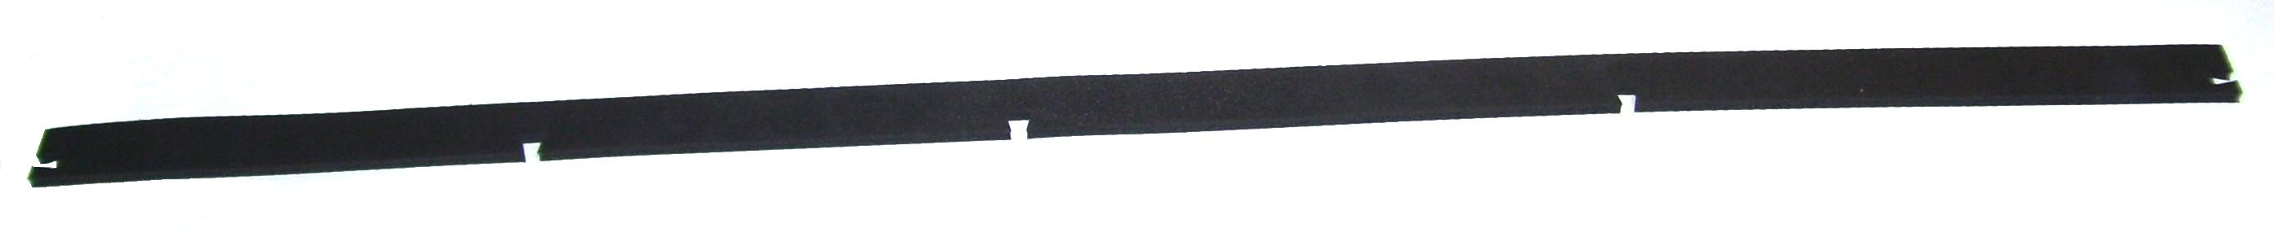


PBL41018

Gasket Waste Tank Lid

1” x 40’

(Adhesive Required – Use PP05-008002)

PHY131-028

Gasket Recovery Tank - Hard

Sold per foot

NM4456

Gasket APO Switch Box

5” x 2-3/4”

PHY131-021

Gasket Recovery Tank - Soft

Sold per foot

PHY131-070

Gasket Recovery Tank

With Top Bulb - Sold per foot

PFA20

Vacuum Relief Seal Kit
Small Water Claw

PFA21

Vacuum Relief Seal Kit
Medium & Large Water Claw

PA010A

Gasket Vac Motor 5.7”

5/8” Thick –

One side Adhesive
Nautilus Portables

NM5526

Gasket Flash Xtractor II

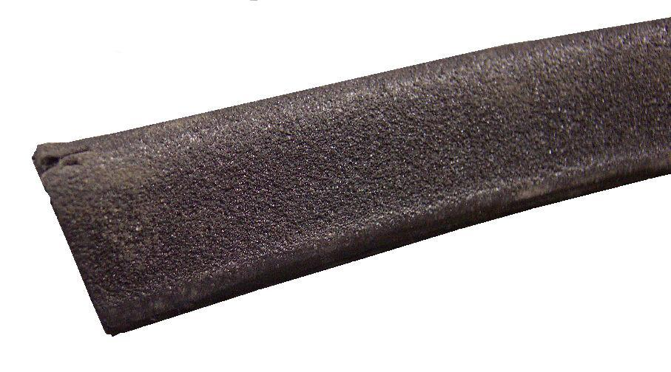
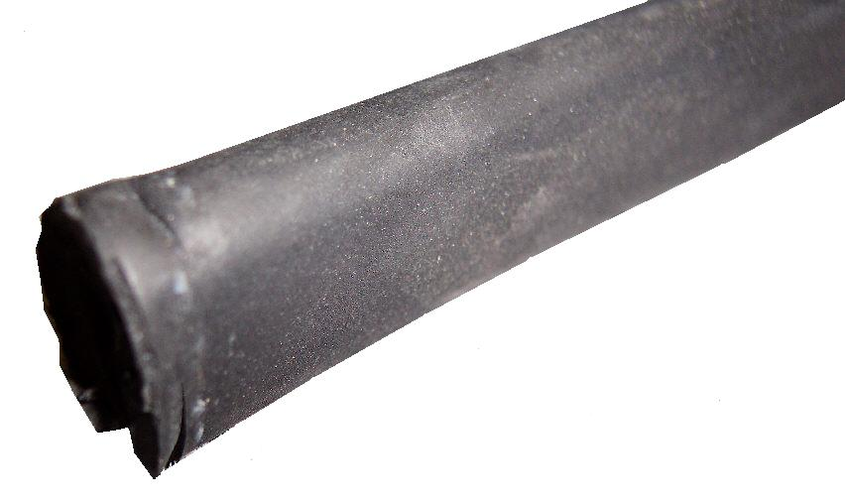
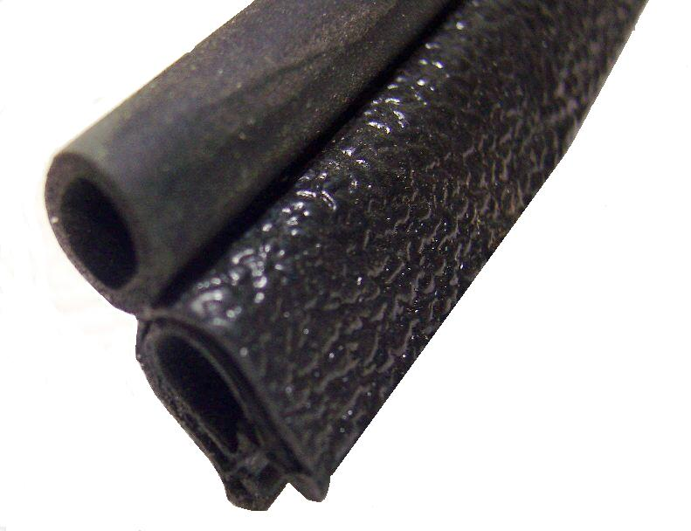
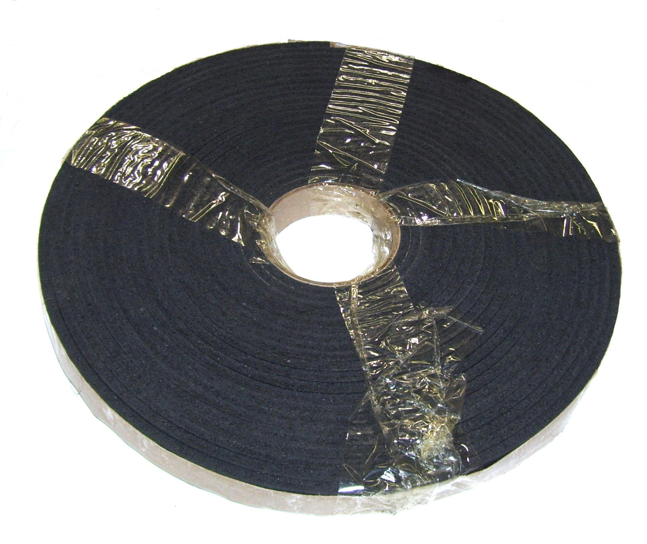
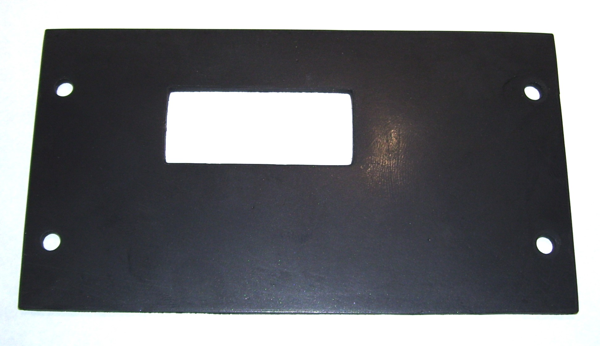
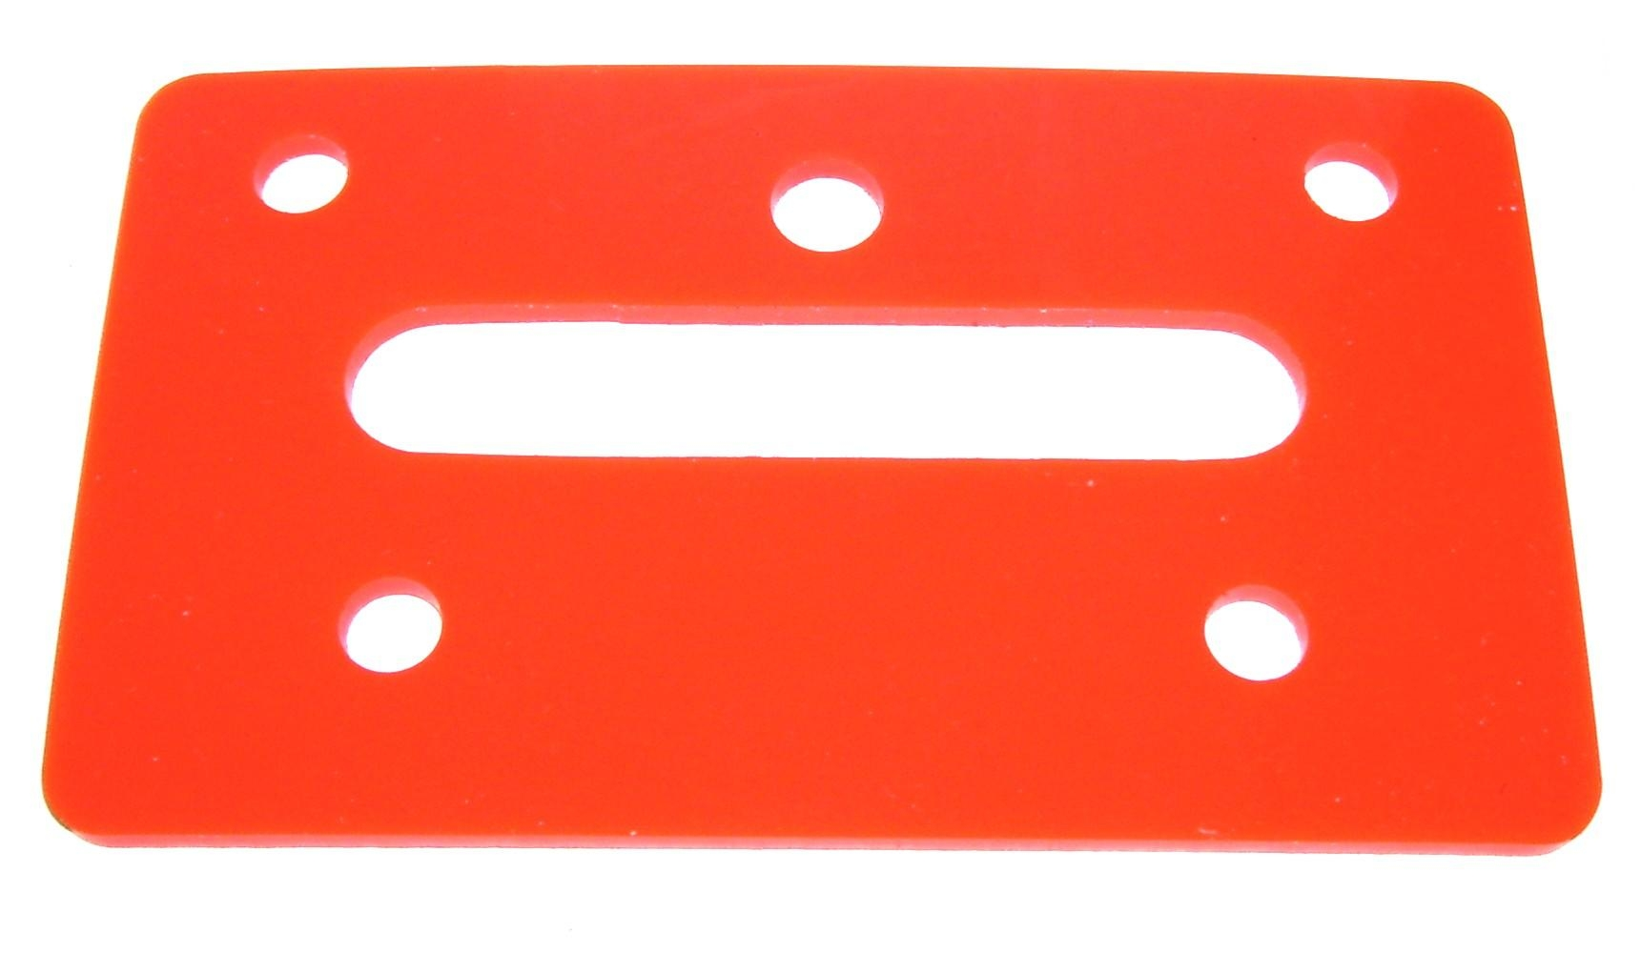

NM4254

Weather Stripping – Per Inch

Nautilus Extractors

NM5630A

Seal - Inner Shell

New Style SX-7

PA010B

Gasket Vac Motor 8.4”

5/8” Thick –

One side Adhesive
Nautilus MX500-HP

